Name: Balu Harish Reddy Maddireddy

Student ID: 801209246

**Project 4**

**Working steps**

* Open the terminal and run node app.

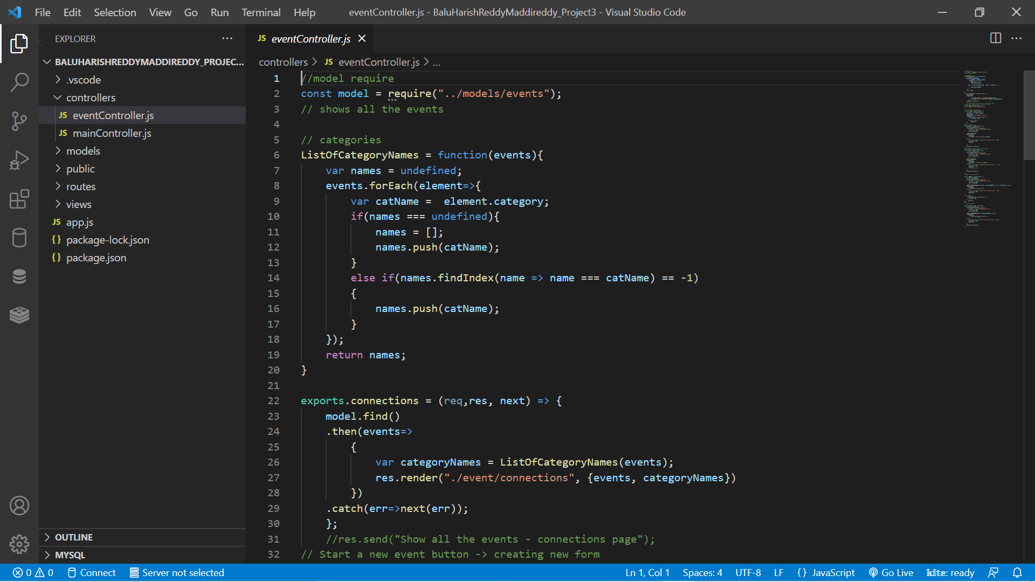

* Open the web browser and enter localhost:3000

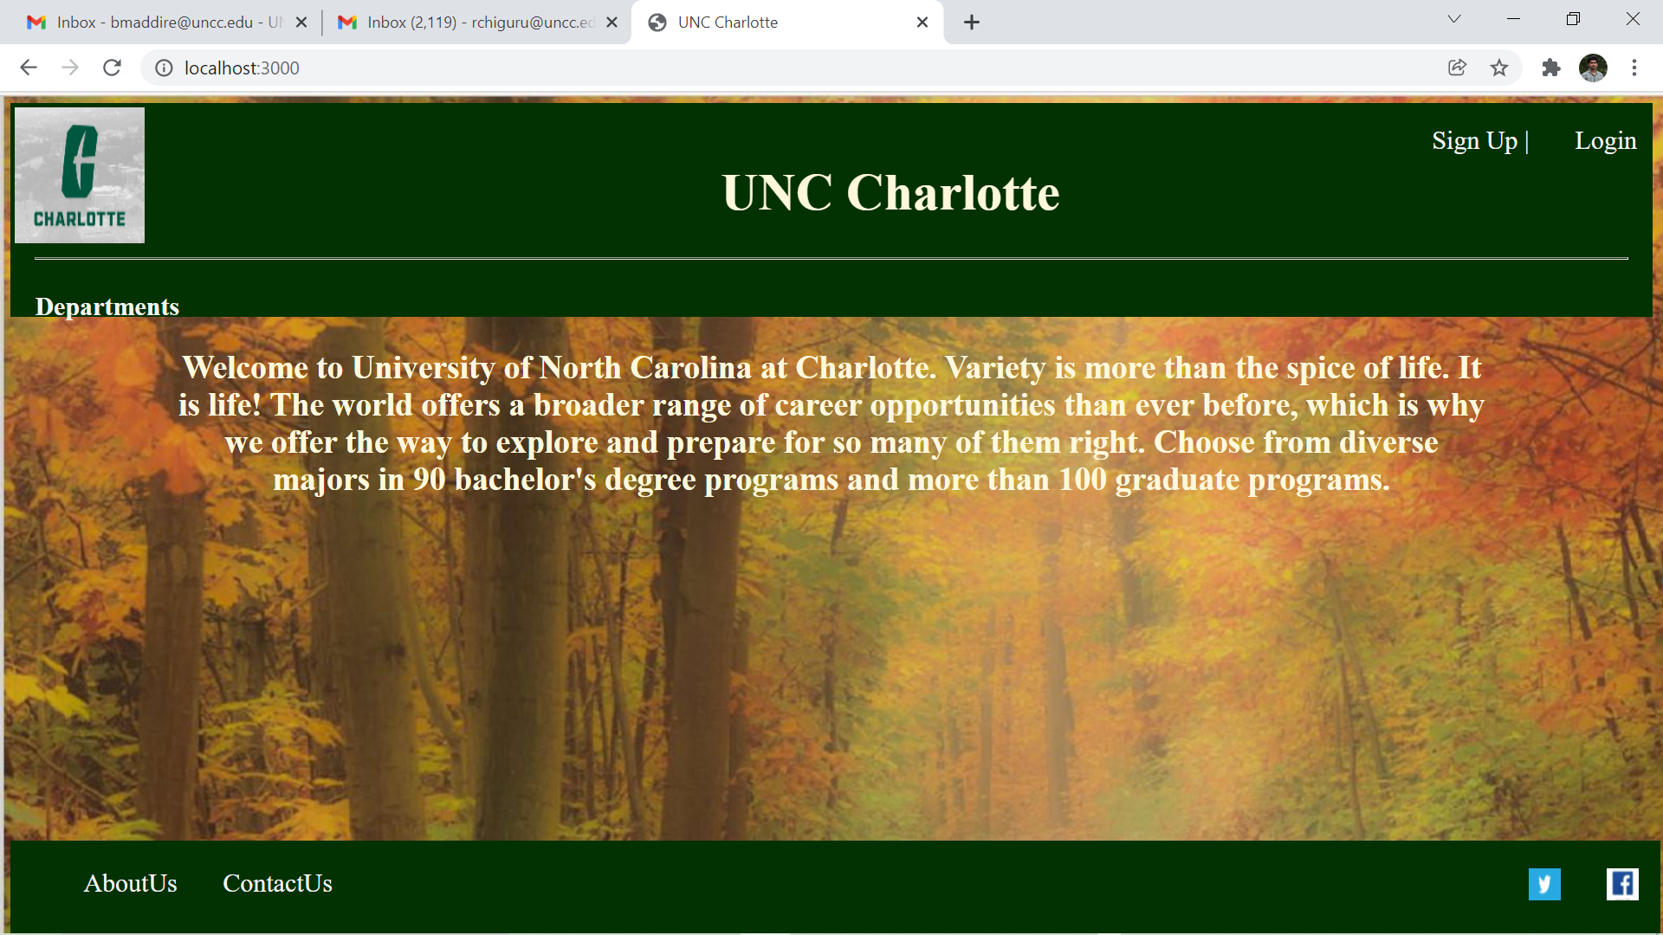

* Click on the portal, it will redirect to portal page:

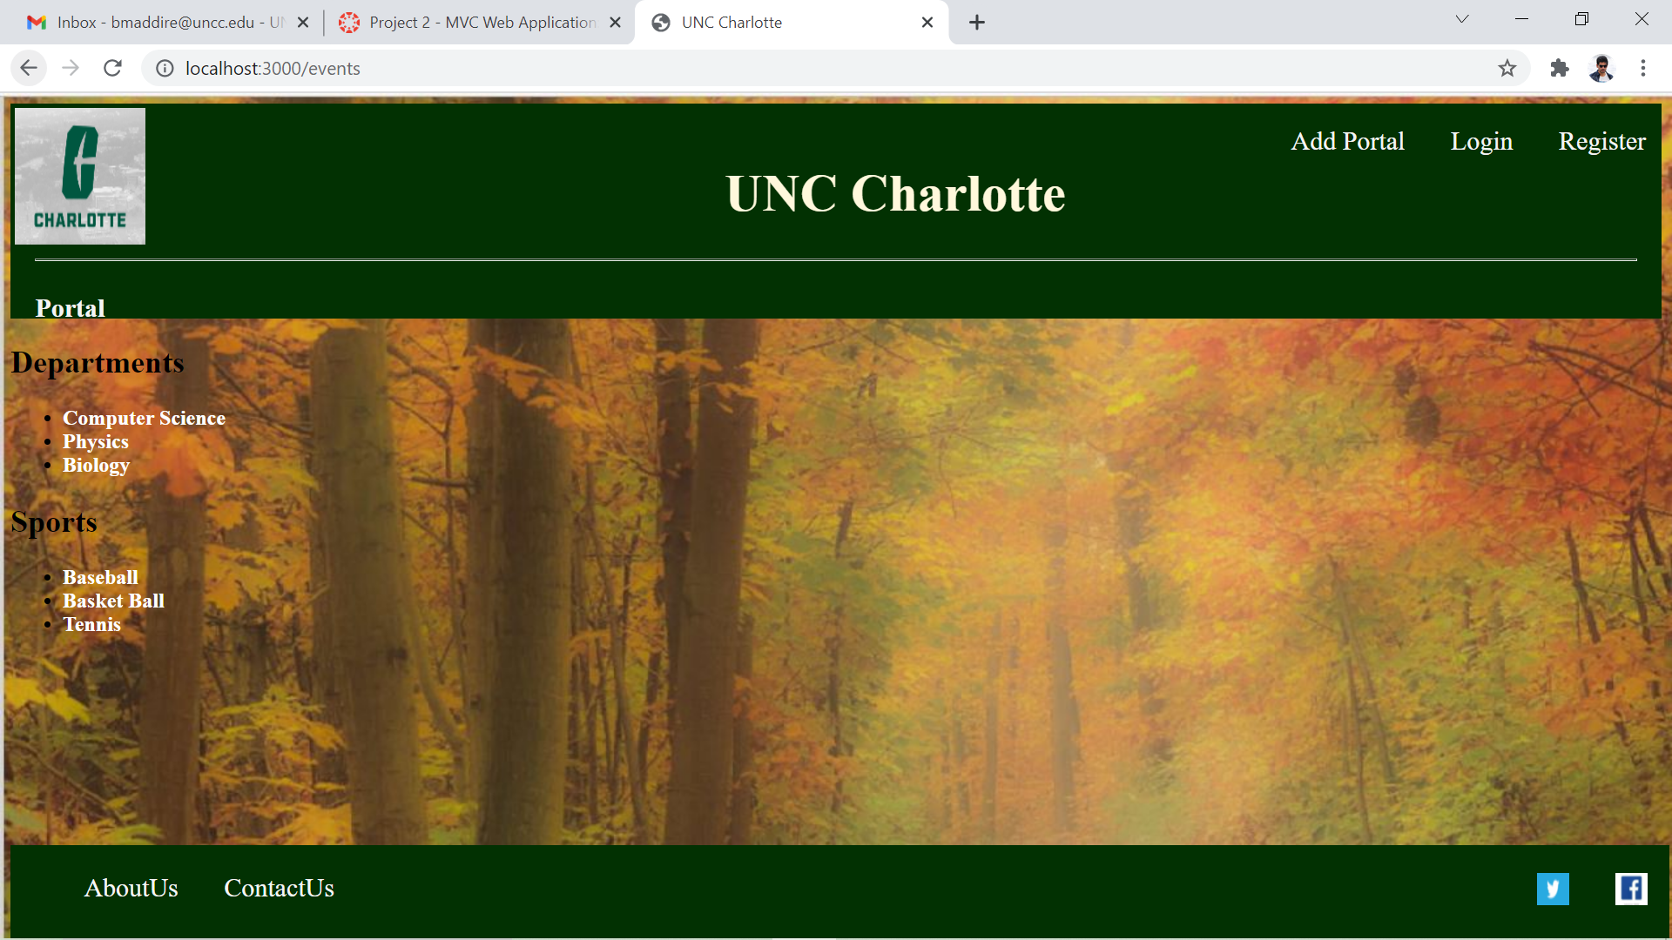

* Click on the portal contents to get the further details. Where we can find two buttons update and delete.

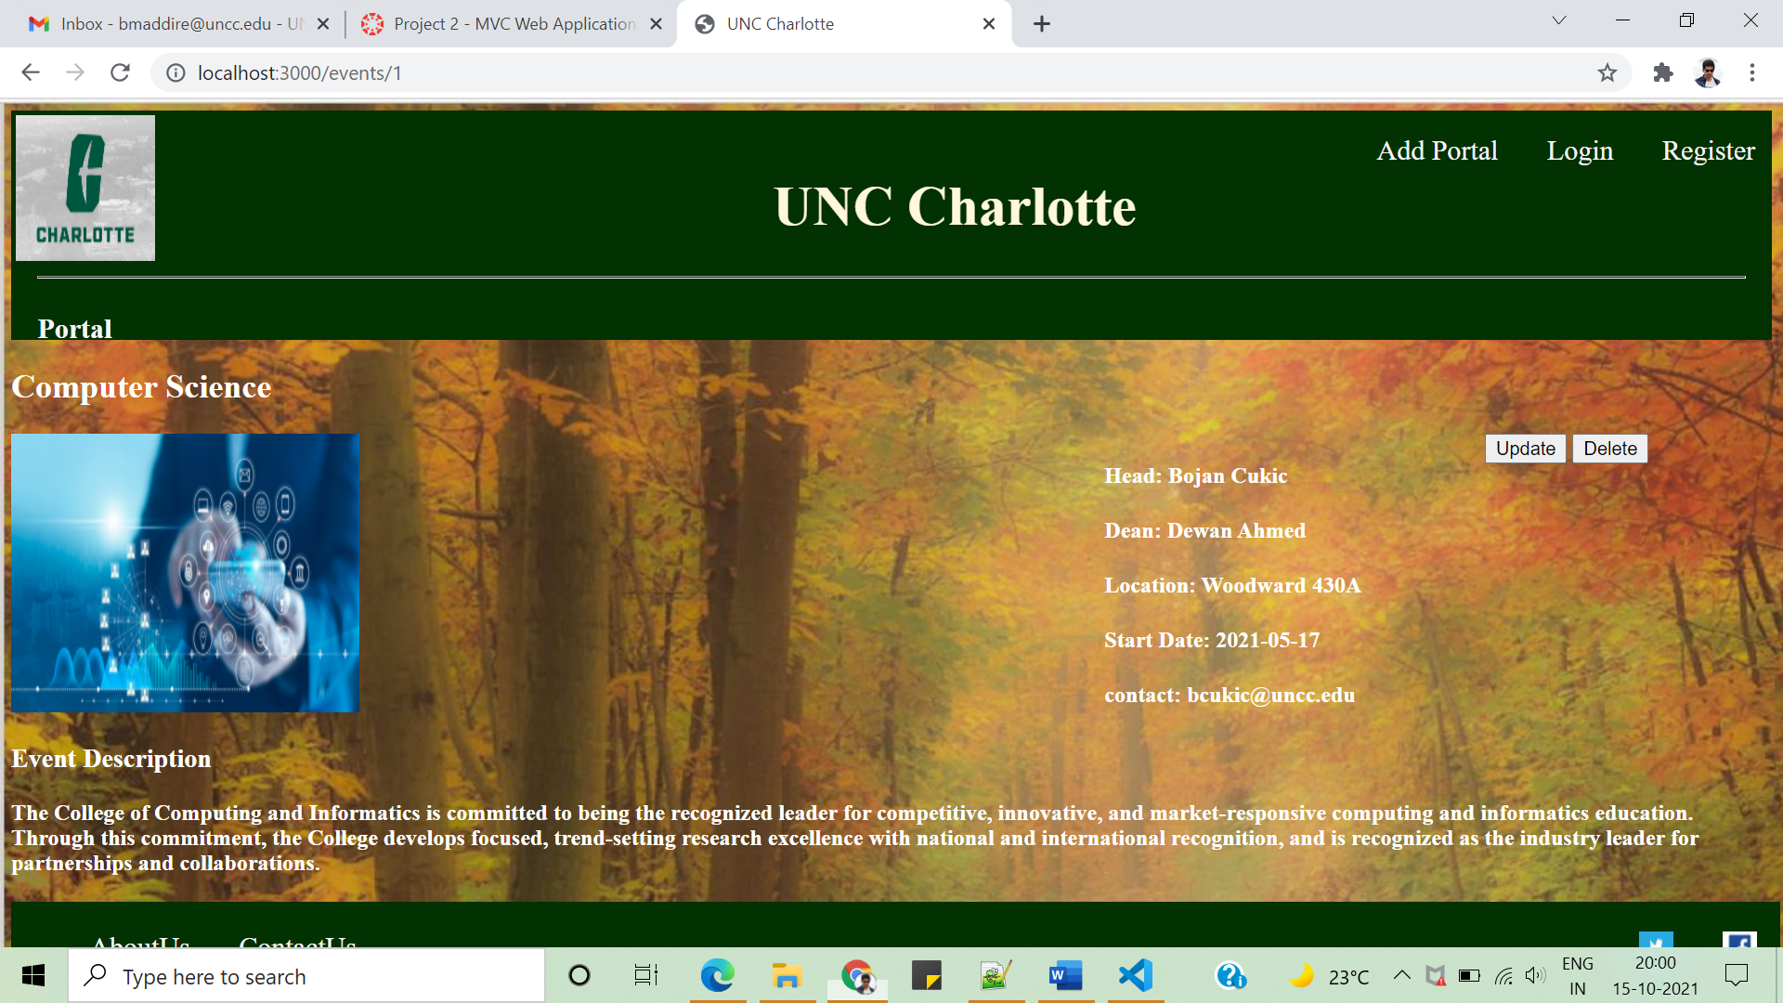

* Clicking on the update tab we can update the details on the departments or sports.

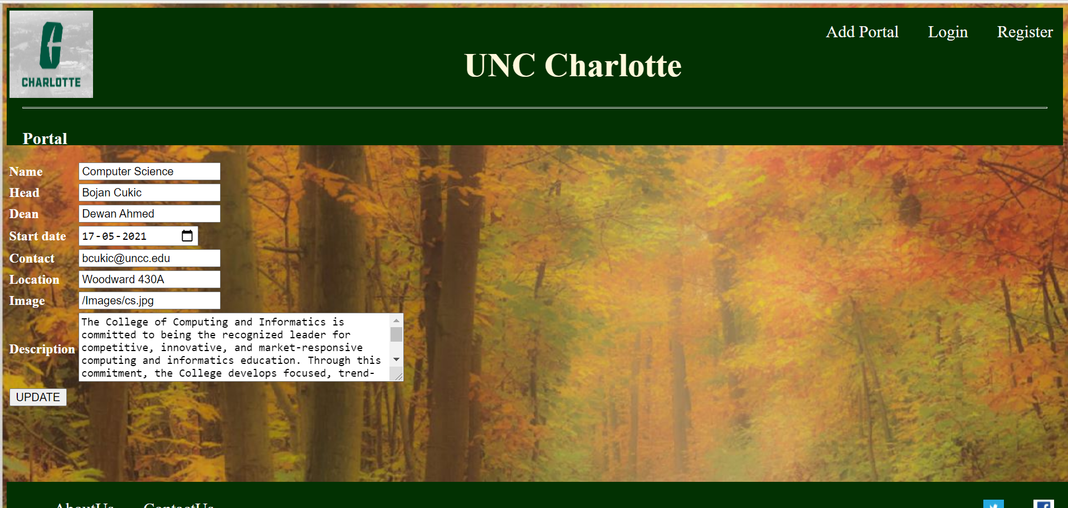

* On clicking **Add Portal;** we can add departments and sports to the portal page.

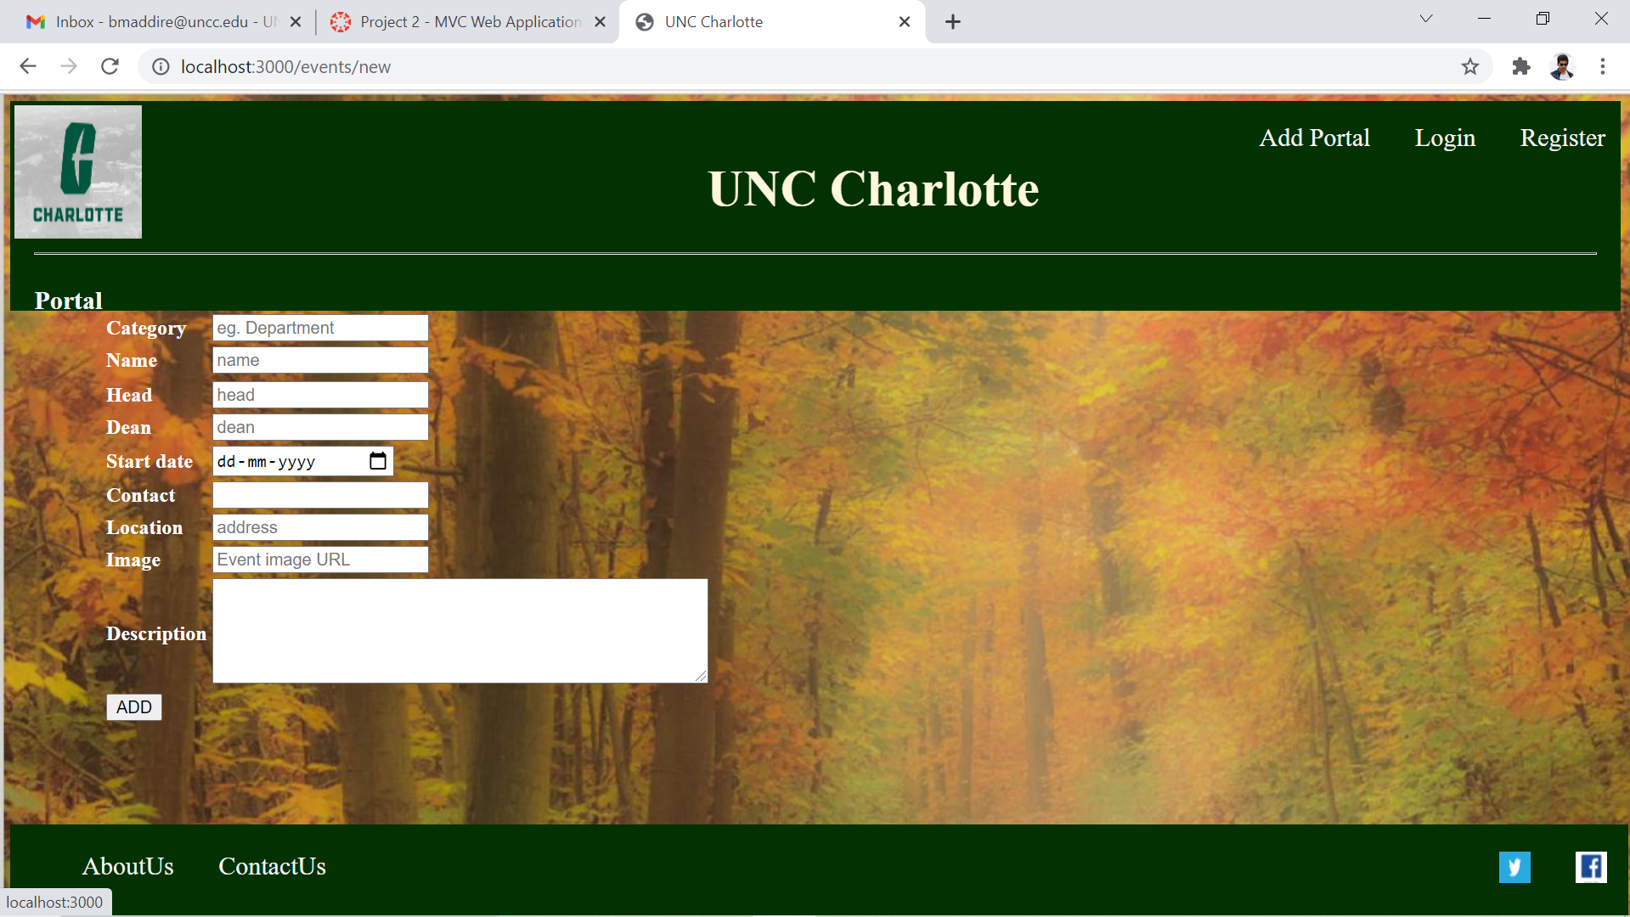

* Clicking on **AboutUs** we can get to know the information the website

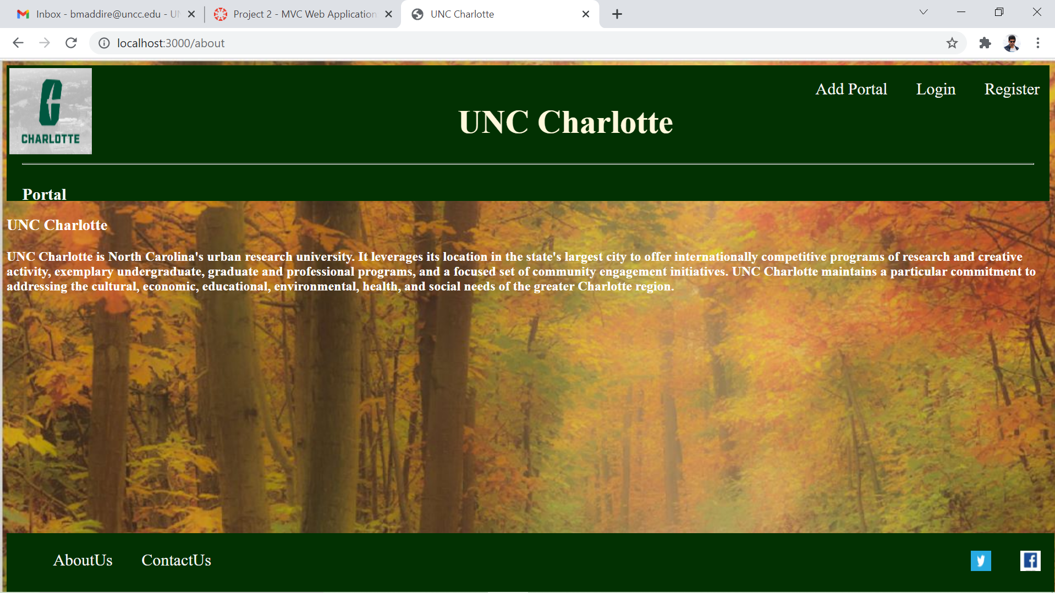

* On clicking on **ContactUs** we can get to know the contact details.

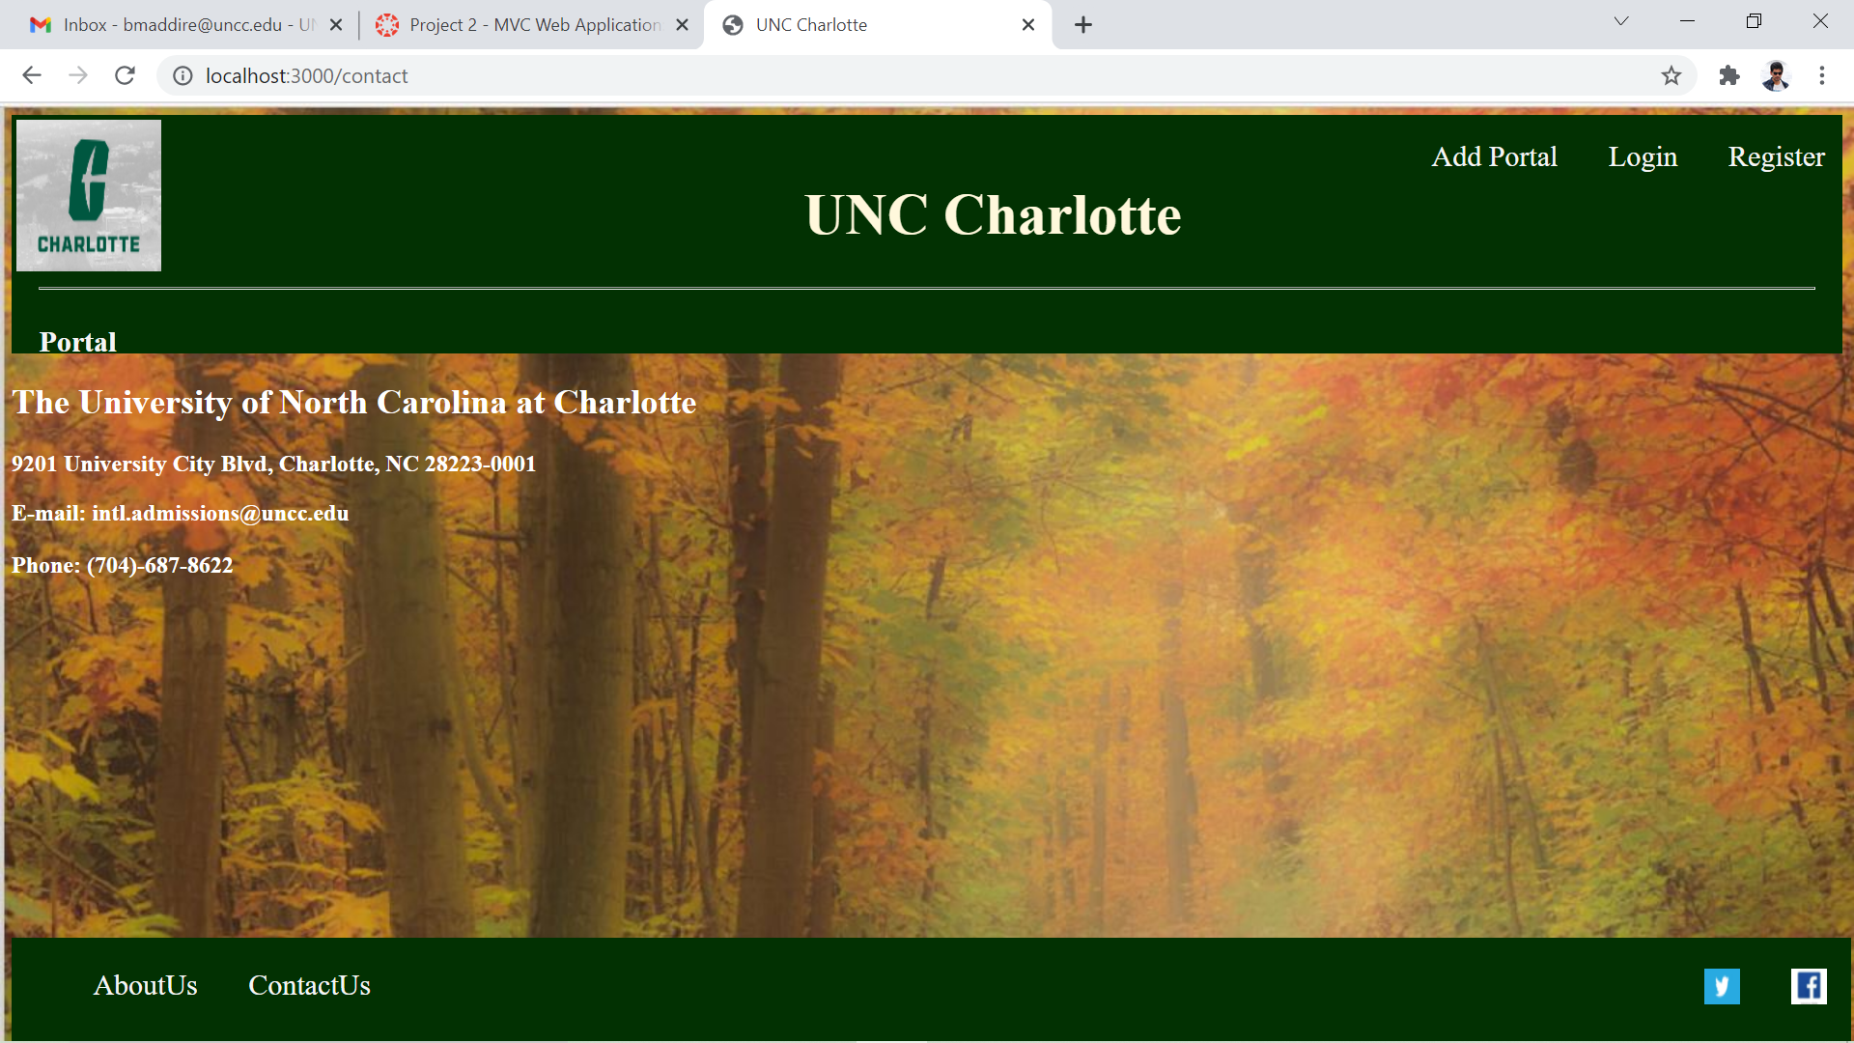

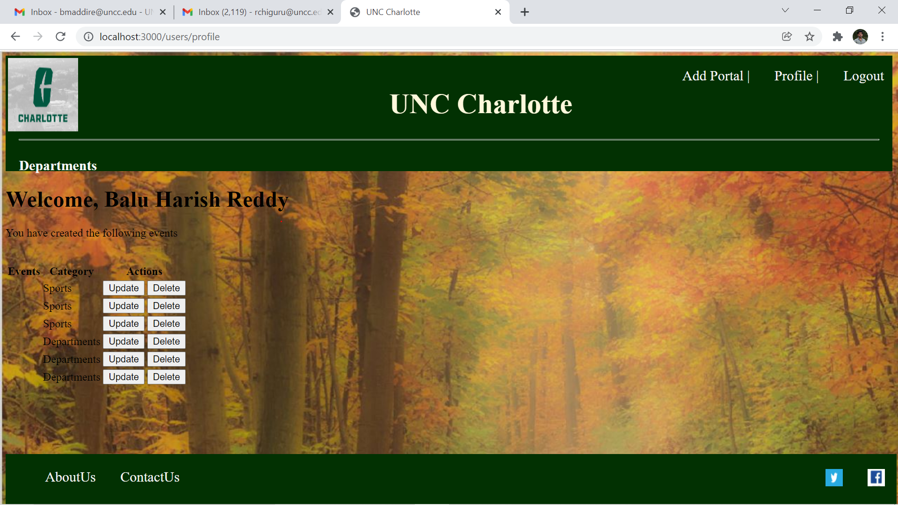

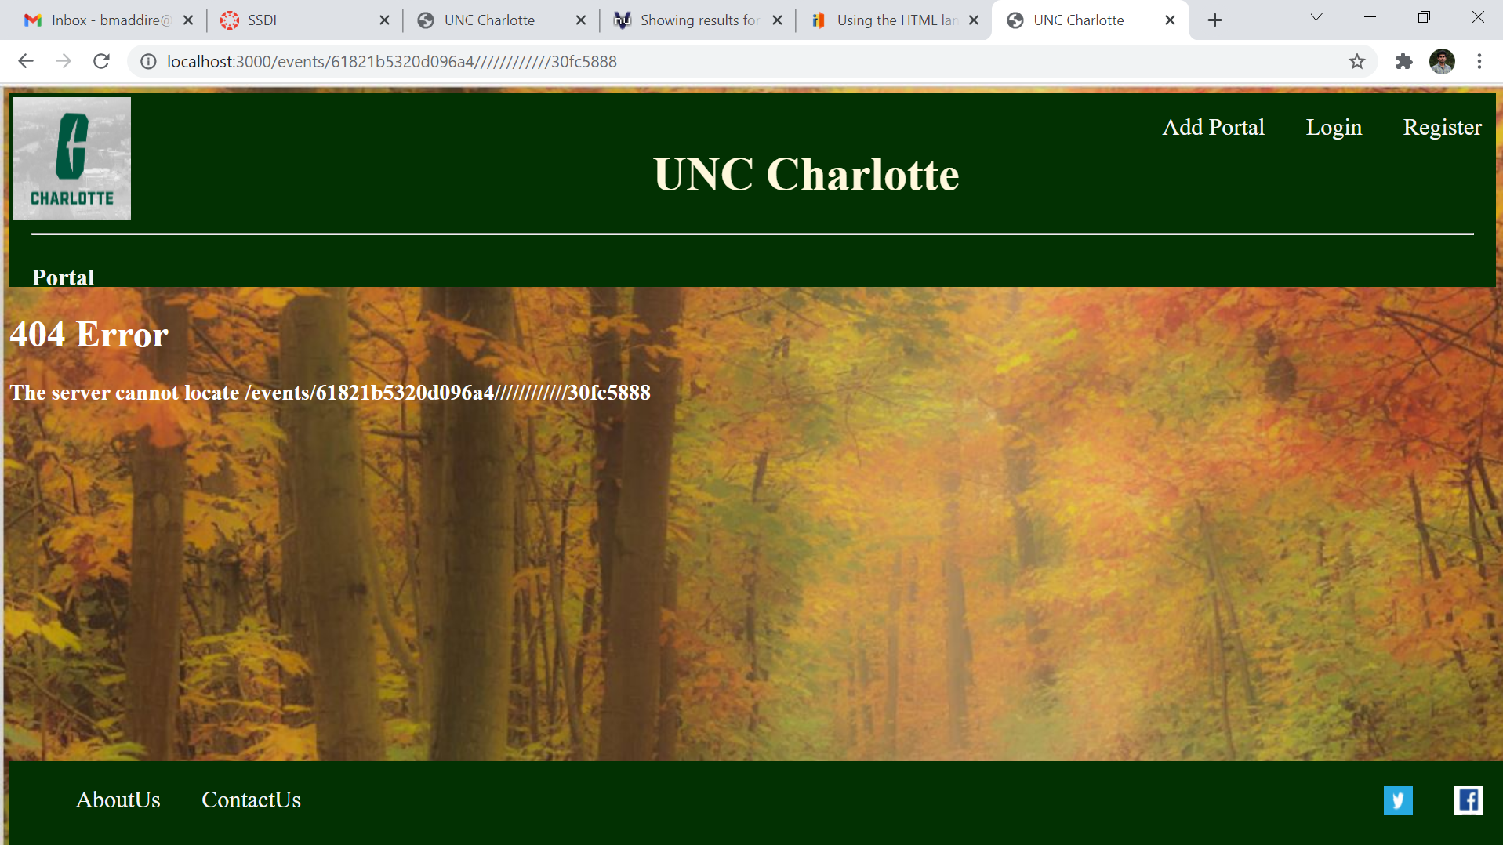

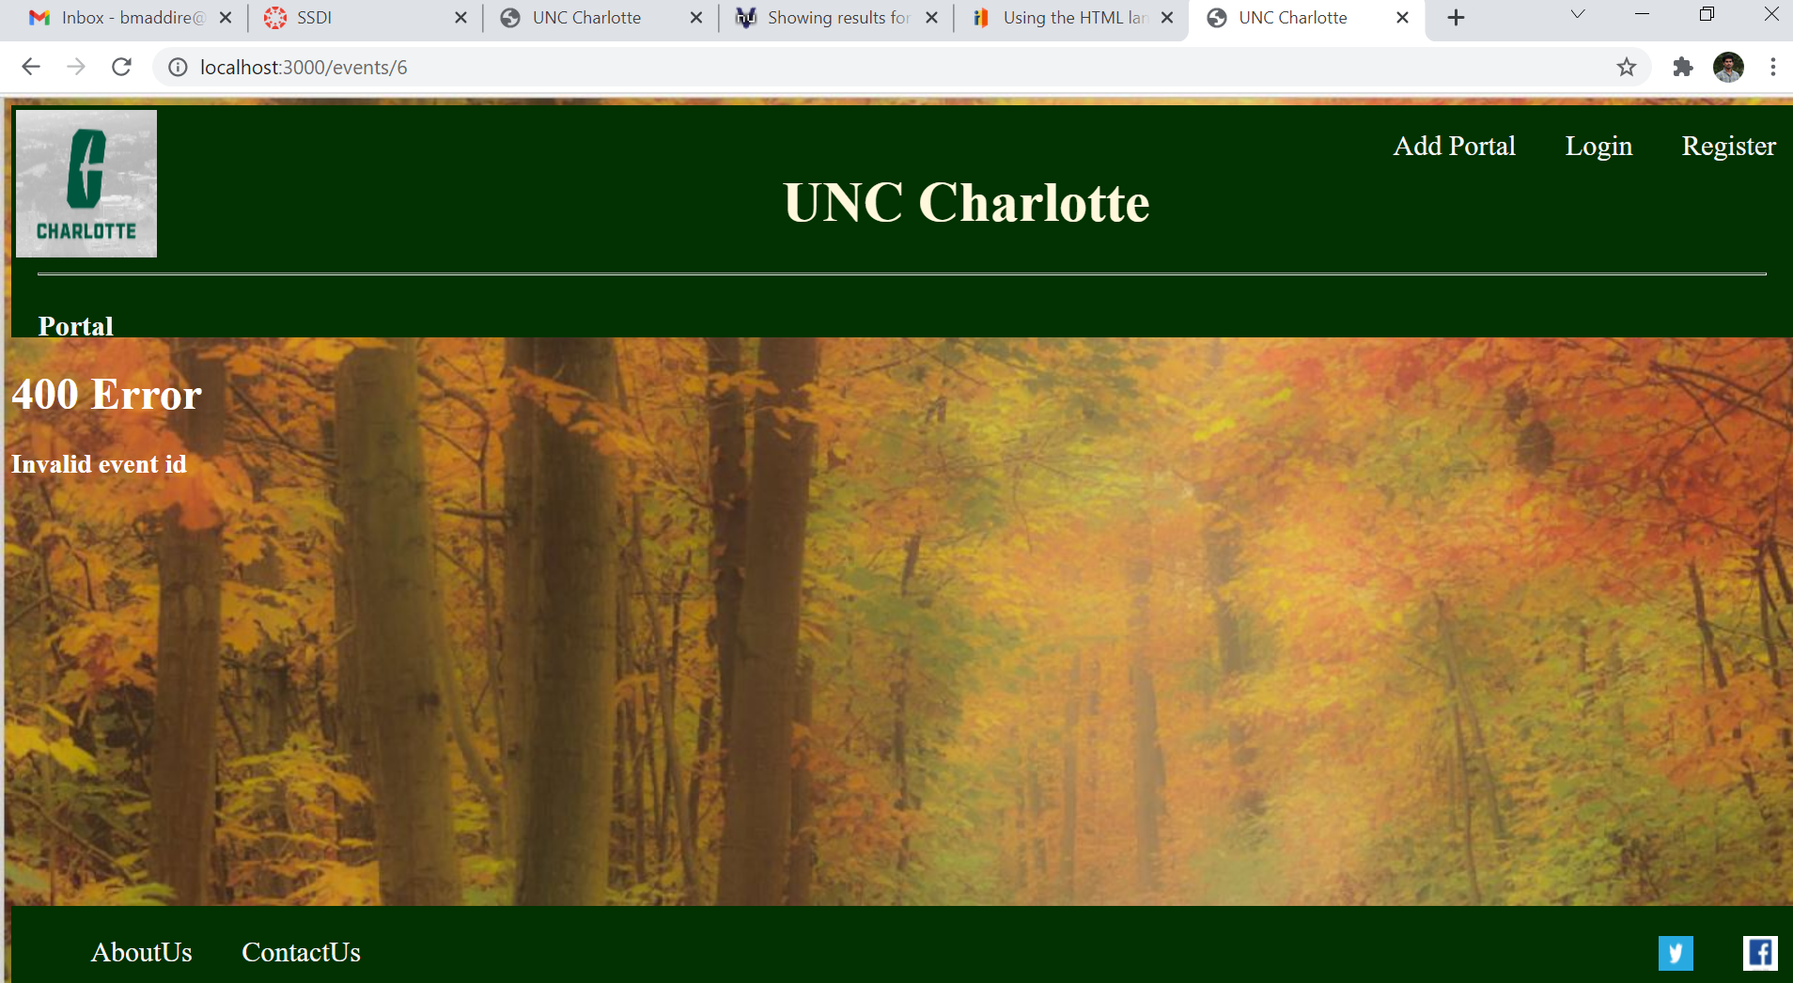

Discuss the easy and challenging parts of the assignment. How did you overcome all or some of the challenges?

**No Challenges.**